**Git-HOL 1**

The following steps were followed to complete this exercise:

1. Checking Git version

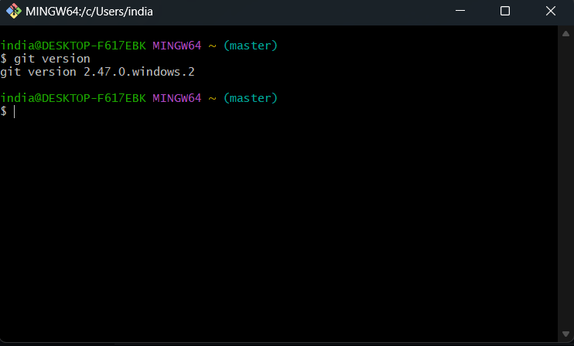

1. Git Configuration

I have used git before therefore, configuration was already setup.

(The screenshot was taken after setting up Notepad++ as default editor.

Therefore, it is also displaying that.)

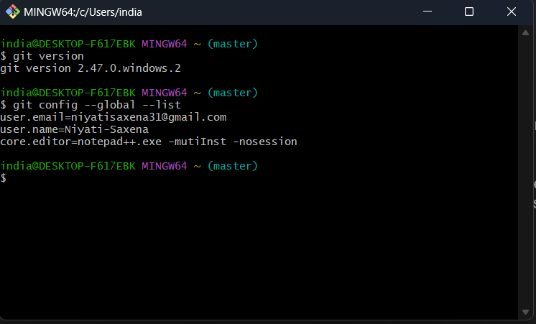

1. Integrating Notepad++

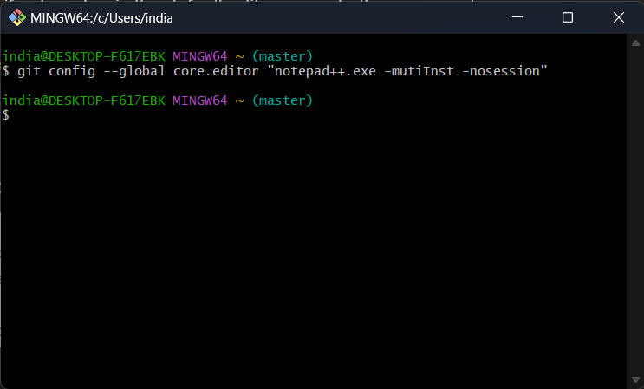

1. Creating GitDemo

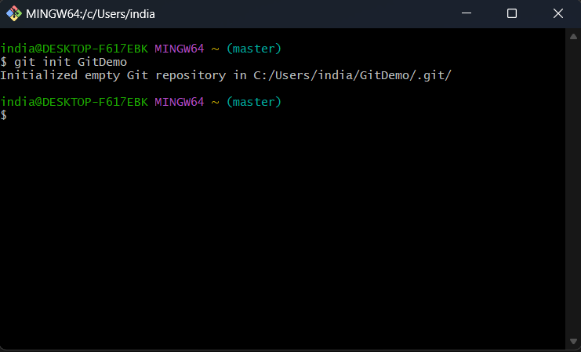

1. 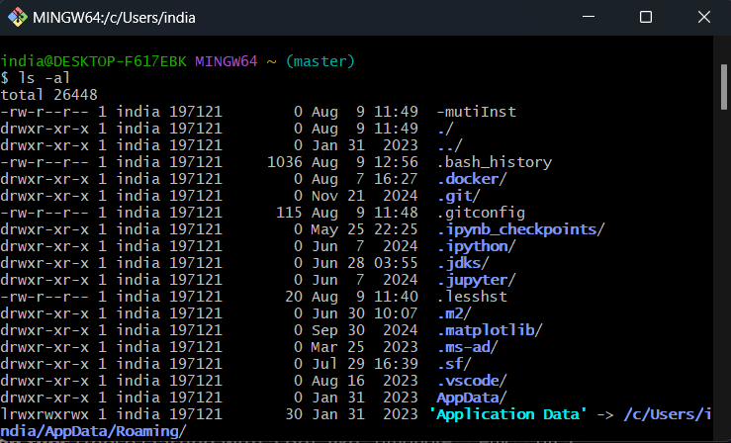Listing down all the files available currently
2. 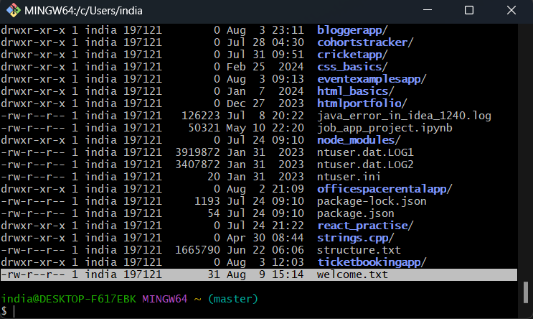Creating Welcome.txt
3. 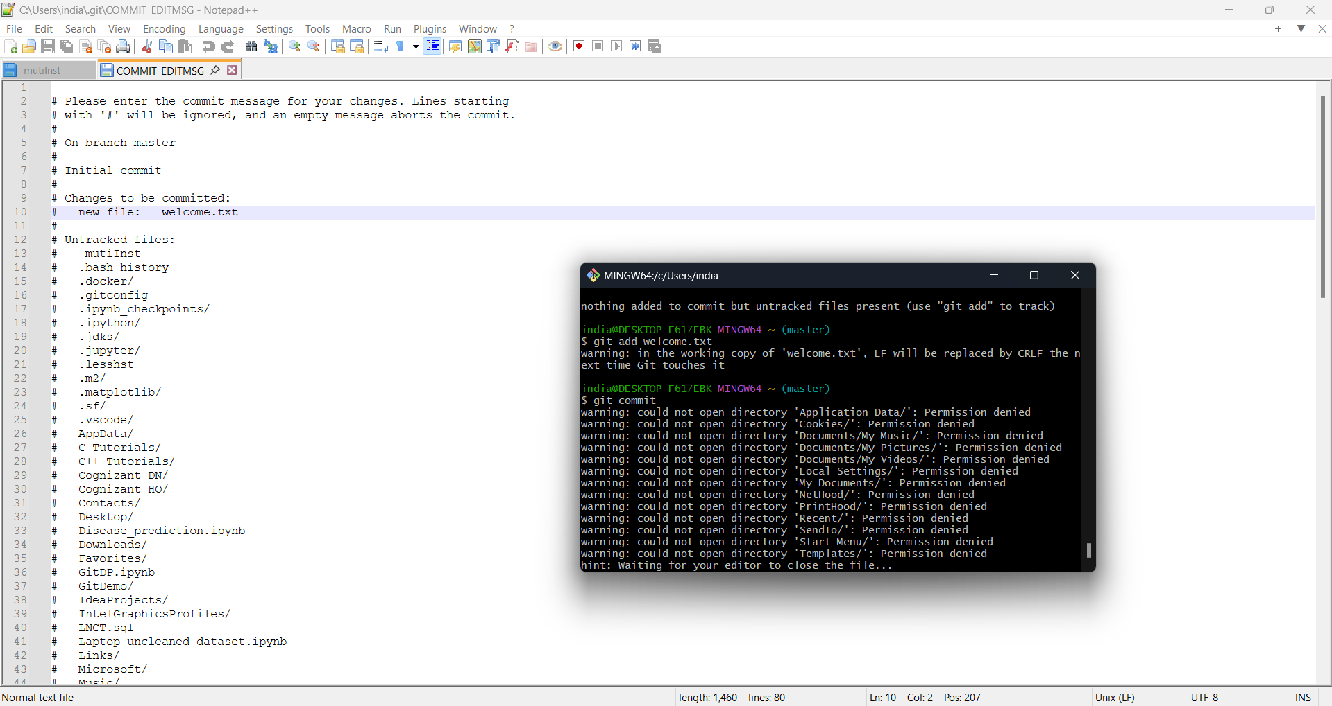Adding and Committing Welcome.txt
4. 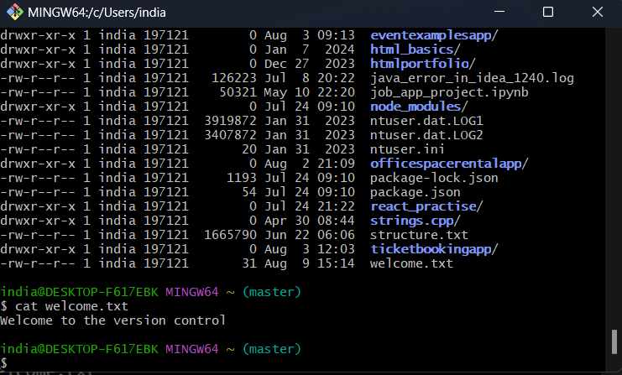Implementing Welcome.txt
5. Created Account on GitLab and ran the following commands

